Public Docker Registry - dockerhub
ajeetkumarv
ajeetkumarv7@gmail.com

Tutorial https://www.youtube.com/watch?v=fqMOX6JJhGo&t=2172s

sample commands
docker run mongodb
docker run nodejs
docker run nginx

Docker image is template used to create one or more containers
Containers are running instances of images that are isolated and have their own envrionemtn

Docker editions
Commnunity edition
Enterprise edition

sudo docker run docker/whalesay cowsay Hello-World!
sudo docker run docker/whalesay cowsay RunningSecondTime

docker run command will run instance of nginx from docker host if already exist. if image is not present on host, it will pull image from dockerhub, only for first time

docker ps - list running containers
docker ps -a list running and previously stopped containers

docker stop <name>/<container id>
docker rm <name> to remove stopped/exited container permanently

docker images to list images

to delete image
check no containers are present (running/stopped) of that image
docker rmi nginx. stop and delete all container debfore deleteing image

docker pull nginx to only pull the image and not run right now

docker run ubuntu this will exit immediately since no service running inside it
docker un ubuntu sleep 5 will exit after 5 seconds

docker exec <continer_name> cat /etc/hosts

docker run kodekloud/simple-webapp
this runs in attached mode, means in foreground
docker run -d kodekloud/simple-webapp to run in detached mode,ie in background
docker attach <id> to attach in foreground

docker run redis will run latest version of redis
docker run redis: latest is the underlying command for above command
docker run redis:4.0 will run this version, this is called a TAG

by default non interactive mode, use -i
docker run -i image_name
will take input without prompt
for interactive mode but not linked to stdin

docker run -it image_name
this will prompt for input, take input and show output

Every docker container gets an ip assigned by default

docker run -p 80:5000 image_name
docker run -p 8000:5000 image_name
all traffic on host 80 is routed to docker container 5000
above two commands are running 2 Containers

docker run -p 3306:3306 mysql
docker run -p 8306:3306 mysql
docker run -p 8306:3306 mysql <---- this will cause error since 8306 mapped already

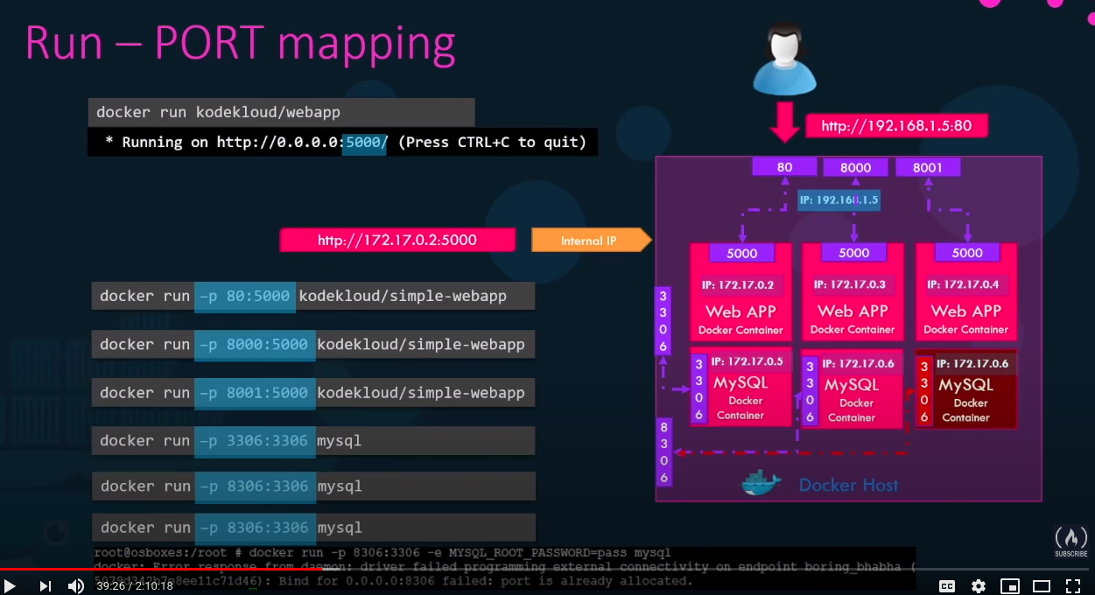

docker run -v opt/datadir:/var/lib/mysql mysql
mapping mysql inside container to data on host

docker inspect <container_name>
will return details in json

docker logs image_name

docker run -e APP_COLOR=blue <image>
this is environment variable

Creating image

docker build Dockerfile -t ajeetkumarv/my-app
docker push ajeetkumarv/my-app
to make it available on public repository

docker build .
docker build-t my-app .
Docker run my-app

Dockerfile template
INSTRUCTION ARGUMENT

Dockerfile Sample
FROM Ubuntu

RUN apt-get update
RUN apt-get install python

RUN pip install flask
RUN pip install flask-mysql

COPY . /opt/source-code

ENTRYPOINT FLASK_APP=/opt/source-code/app.py flast run

docker histroy <image>
to see the details how image was created

Example image name sleeper
FROM Ubuntu
CMD sleep 5

docker run sleeper sleep 10

FROM Ubuntu
ENTRYPOINT [“sleep”]

docker run sleeper 10

FROM Ubuntu
ENTRYPOINT [“sleep”]

CMD [“5”]

this makes 5 as default command

Replacing ENTRYPOINT while running
docker run –entrypoint sleep sleeper 10

By default container attaches to Bridge network
docker run ubuntu
docker run Ubuntu --network=none
docker run Ubuntu –network=host

Birdge is the private network created by docker on host
docker network ls
docker inspect <container_name>

containers resolve each other using their name
docker DNS ip is 127.0.0.11

Storage
/var/lib/docker
aufs
containers
image
volumes

Compose
docker-compose.yml
services:
web:
image: “my-app1”
database:
image: “mongodb”

docker run -d --name=redist redis

docker run -d –name=vote -p 5000:80 --link redis:redis voting-app

if using private registry
docker login private-registry.io
docker run private-registry.io/apps/internal-app

cgroups or control groups to control container access to resources
docker run –cpus=.5 ubuntu
max 50% of cpu
docker run --memory=100m ubuntu
100mb max

Mosh

docker build -t hello-docker .
dot at the end is where docker can find Dockerfile, so current dir in this case.
docker images
or
docker images ls

docker run hello-docker
docker run -it hello-docker bash
bash means command to start with
docker run -d hello-docker
detached more, means background
docker run -d --name blue-sky hello-docker

docker logs -f 123
follow the logs by container_id 123
docker logs -n 5 -t 123
last 5 lines with timestamp for container_id 123
docker run -d -p 80:300 react-app
80 of host to 3000 of container

Sending commands in running container
docker exec react-app ls
run ls in WORKDIR ie /app in container
docker exec -it react-app sh
connect to sh shell interactive
docker stop react-app
docker start react-app
with docker run you start a new container
with docker start u start a stopped one.
react-app can have many tags, use the tag to start or stop or container id

play-with-docker.com

docker pull codewithmosh/hello-docker
docker ps -a // to see stopped containers.

docker ps -it ubuntu// interactive mode

by default docker runs with root user

Dockerfile
FROM
WORKDIR
COPY
ADD
RUN
ENV
EXPOSE
USER
CMD
ENTRYPOINT

FROM node:latest
by default uses latest, always use with version

eg dockerfile
if source file has space in it's name
COPY ["hello world.txt", .]
file to curr dir in image

WORKDIR /app
COPY . .
means curr dir in project to curr dir image

if you want file from url or ucompress a commpressed file we can
ADD http://../file.json .
ADD file.zip .
file.zip will be uncompressed

docker run react-app npm start
last is the command to run after starting.
or you can move npm start to Dockerfile end
if you put multiple CMD only last one is effective.

docker run react-app --entrypoint

Shell form, this is run in separate shell
CMD npm start

Exec form
CMD ["npm", "start"]

ENTRYPOINT ["npm", "start"]

docker images
shows dangling images too or loose images
docker was creating these layers and lost the relationship with these layers. we can prune them

docker container prune
remove stopped containers
docker image prune

docker image rm hello-docker some-app
docker build -t react-app:busted
or
docker build -t react-app:3.1.5

docker images tag react-app:latest react-app:1
give additional tag 1
docker image tag b06 react-app:latest
so that image points to latest tag

Volumes
since we never store data on container file system
we use volume, can be dir on host or cloud

docker volume inspect app-data
docker run -d -p 80:3000 -v app-data:/app/data
-v for volume
if any of dir is not present docker will create it.

docker cp containerid:/app/log.txt .
docker cp secret.txt containerid:/app

docker run -d -p 80:3000 -v $(pwd):/app react-app
pwd is linked to /app in containers to changes are linked immediately

a repo can have multiple tag, to remove
docker image remove react-app:1
this will remove tag 1

to docker hub
docker push codewithmosh/react-app:2

docker image save -o react-app.tar react-app:3
docker image load -i react-app.tar

---------------------
Failed to compile.

EACCES: permission denied, mkdir '/app/node_modules/.cache'

This could happen if project build was done with diff user and you switched to diff user at the end.
in our case we switched to app user in the end, so move it upwards in file.

-----------------------

linux
apt: advanced package commands
apt list (all might not be installed)
apt update (update the package database from variour sites)
apt install nano
apt remove nano

grep -i hello file*
search case insensitive word hello in file* files
grep -i -r hello .
look for hello in curr dir (-r isimp)
find
shows all files in curr dir
find -type d
show only dirs, if used f show only files
find -type f -iname "f*"
i is for case insensitive
mkdir test ; cd test ; echo done
run command in sequence. but no fail proof
mkdir test && cd test && echo done
if mkdir fails, cd and echo won't be executed
mkdir test || echo 'dir exists'
if first one works, echo won't run
if first fails, echo will run
ls /bin | less
less uses outpuf of ls
printenv
useradd
usermod
userdel
check impact on /et/passwd file*
passwords are store in /etc/shadow file
adduser bob
this uses useradd underhood and verbose
for permissions
rwxrwxrwx first one is self, then group, then others
by default user is put in group of self name
ugo user group others
chmod u+x file.sh
chmod og+x+w-r file.sh
adding user execute permissions

Mosh
docker build -t firstapp .

I was getting below error
Got permission denied while trying to connect to the Docker daemon socket

sudo usermod -a -G docker ajeet

sudo docker image ls or sudo docker images
to list all images

sudo docker run firstapp
sudo docker pull <username>/imagename

docker ps
docker ps -a // for stopped containers also

docker run -it ubuntu // -it is interactive

#=============== LEARN Linux

echo $0 current process location

history -c to clean all history
!2 to run second command in the history

apt is package manager for ubuntu stands for AdvancedPackageTool

apt-get is low level and for backend, remains backward compatible

apt update means update the repository of package
apt install nano means install the nano
apt remove nano ro remove it.

etc => editable text configuration
var => variable, keep files that are updated freqyenty like logs
proc => represents files running processes

more can not scroll up
less is a newer command that more

